

The Worshipful Company of Carmen
Plaisterers’ Hall, 1 London Wall, London, EC2R 5JU

Tel: 020 7645 1405 (Clerk) Extension 1 (Deputy Clerk) Extension 2
VAT Registration No. 446 9401 35
WEBSITE: www.thecarmen.co.uk E-MAIL: carmencompany@btconnect.com

MASTER
MR MARK GRIFFITHS

We would be delighted to receive your recommendations for this year’s awards by you giving us as much information as possible about your nominee. The committee will decide which award category they fall in and we can assure you that every nomination will be looked at and discussed in detail.
NATIONAL AWARDS 2016

Below are 2015 main award winners collecting their trophies and citations at Mansion House on 8th March 2016. From left to right: Sir Henry Royce Award – The Port of London Authotity; Carmen’s Environmental Award – Peel Ports; The Herbert Crow Award – CILT Knowledge Centre.
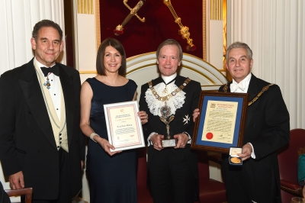
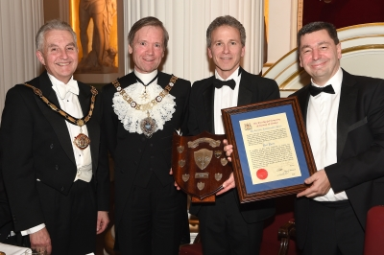
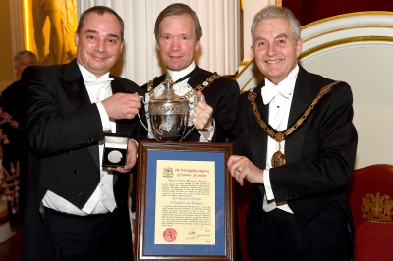

NOMINATIONS (to be submitted at the Awards Committee Meeting in November 2016)

NOMINEE……………………………………………………………………………………………

DESCRIPTION of product, activity, person or event nominated
(Please be as precise as possible in describing your nomination and continue overleaf if necessary)

………………………………………………………………………………………………………..
………………………………………………………………………………………………………..
………………………………………………………………………………………………………..
………………………………………………………………………………………………………..
CONTACT NAME for NOMINEE……………………….…………………………………………
ADDRESS………………………………………………….………………………………………..
………………………………………………postcode…………………….tel…………..…………
YOU MUST GIVE A CONTACT NAME AND NUMBER FOR YOUR NOMINEE

Please give your name, contact number and enclose any other documentation before returning to the Clerk at: Five Kings House, 1 Queen Street Place, London EC4R 1QS by 31 October 2016
NAME……………………………………………………..TEL…………………..……………….
Committee Member Advisor Carman Other ………………..………
Your form may be passed to a Committee Member/Advisor who might contact you for further information and will then present your submission to the Awards meeting for approval at the January Court meeting.

